



**Volley Viction**

**Prepared by: Krishna Naik (1896930)**

**Lilu Odedra (1896615)**

**Urvi Arora (1895757)**

**Shivdeep Kaur (1896567)**

**Pulkit Sharma (1896330)**

**MAD-314**

Table of Contents

1. Project Description 1

2. Requirements 2

2.1 Functional Requirements 2

2.2 Non-Functional Requirements 3

3. Mockups 4

# 

1. **PROJECT DESCRIPTION**

The volleyball management mobile app will function in Android mobile phones. Volleyball management application will cover every aspects of this sport.This application will able to manage the league easily. The application will be used to manage theteamsand players that participate in the league. This Application will be designed in a way, that can be easily understandable to not only guests but also to league managers and team managers.

Basically, this application provides three types of roles, who can use this application such as league managers, team managers and guests. Where, league managers will be able to create and delete teams, seasons and also, they can create match schedules and can modify or enter match results. Team managers also have preceding role where they can edit information of their team. Every team have single team manager who can manage that team. Team managers have authority to add or delete their players. This is very easy way to define that each role can manage their duties effortlessly. League manager have same rights as team manager. For confidential reasons only league managers and team managers can login to the application. And, Guests can use this application by keeping up with match schedules, winning teams, losing teams and other statistics. Guests have no authorities to make changes or make modifications to the application.

Here, we will be using Android studio to build our application. This application will be used by android phone users. The android app will be developed in Android Java. The REST API will be developed in .NET in conjunction with Microsoft SQL Server 2017 Database.

The purpose of this documentation is to describe the application requirements and to track the development of an application. So, this document will be in the interest of a stakeholders who are interested in an application development and the developers who will be developing an app.

1. **REQUIREMENTS**
   1. **Functional Requirements**

The functional requirement provides the behavior of the system as it relates to the system's functionality. In simple words, it should be the ways in which the application should work.

This Application is classified between 3 users and so the functional requirements for all the users may vary.

1. **League Manager**

* League Manager have to login to the Application. Non-registered user or without logging in, they cannot access the application.
* Cegep Volleyball League is managed by League manager. User can organize seasons for the tournament. User can create schedules for the seasons.
* The League Manager can manage all teams in the tournament. User can add the new team to the season and/or can remove the team from the tournament and update team’s information like Name,Contact details.
* Add and/or Delete the player/s of any team, and can edit their information and also update information of the respective Team Manager.
* League manager is responsible to update the results of each match after every tournament.
* League Manager can manage their personal information like Contact Information.

1. **Team Manager**

* Team Manager have to be registered/login to the Application. Non-registered user or without logging in, they cannot access the application.
* Team Manager is bound to single team. User can manage only one team. One Team also has only one Team Manager.
* Team Manager can edit team’s information like Name, Color, Contact Information and ranking.
* Manager can update the Player’s information like Name, DOB, Contact Details and also can add/remove any player in the team.
* Team Manager can update his personal information, Contact information.

1. **Guest**

* Guest can view all the teams of the League. They can view the details of the teams like the leader board and rankings.
* Guest can able to see the events of the day. They can also able to check out the upcoming events for the league.
* The Guest can view statistics of all the teams in the tournament.
* Guest who uses the application has no right to make any modifications or change the information in the application.
  1. **Non-Functional Requirements**

The non-functional requirement shows the running characteristics of the system. The basic and foremost requirement is efficiency and effectiveness of the app. If the app does not run smoothly and fast then nobody would show interest in using the app. Apart from these other non-functional requirements are:

* Up-to date: System should be updated when there is change from league manager or team manager.
* Performance: The System should behave accurately depending upon the server connection strength as well as from the database on which the data is taken from. The performance also depends on the device on which the application is running.s
* Maintainability: Maintaining the\ data of the tournament, players and related users and maintain it in timely manner.
* Security: System should only be accessible by the authenticated users.
* Accessibility: The System will be an android based application and going to be accessible on android phones.

1. **MOCKUPS**
2. **LEAGUE MANAGER**

**FIG 1: MENU PAGE**

This screen represents different actions, such as, teams, players, sign out etc. that the league manager can take.

**FIG 2: TEAM LIST**

This screen displays different number of teams. League manager can also edit teams.

1. **A screenshot of a cell phone

   Description automatically generatedTEAM MANAGER**

**FIG 1: MENU PAGE**

This screen represents different actions, such as, schedules, players, sign out etc. that the team manager can take.

**FIG 2: TEAM DESCRIPTION**

This screen displays the entire description of a particular team, such as, Team’s logo, total number of players etc.

**FIG 3: SCHEDULE PAGE**

This screen represents the schedule of a particular team. The team manager can view the venue, it’s date and timings and total number of matches that are going to take place.

1. **GUEST**

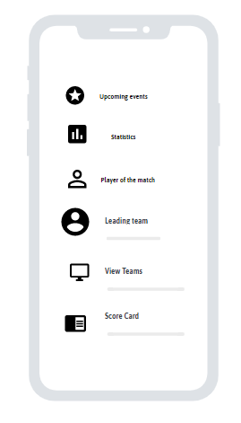

**FIG 1: Main Page**

If a new user opens the application, they can view the statistics, leader boards, upcoming tournaments and trivia about the tournament.

1. **Use Case Diagram:**

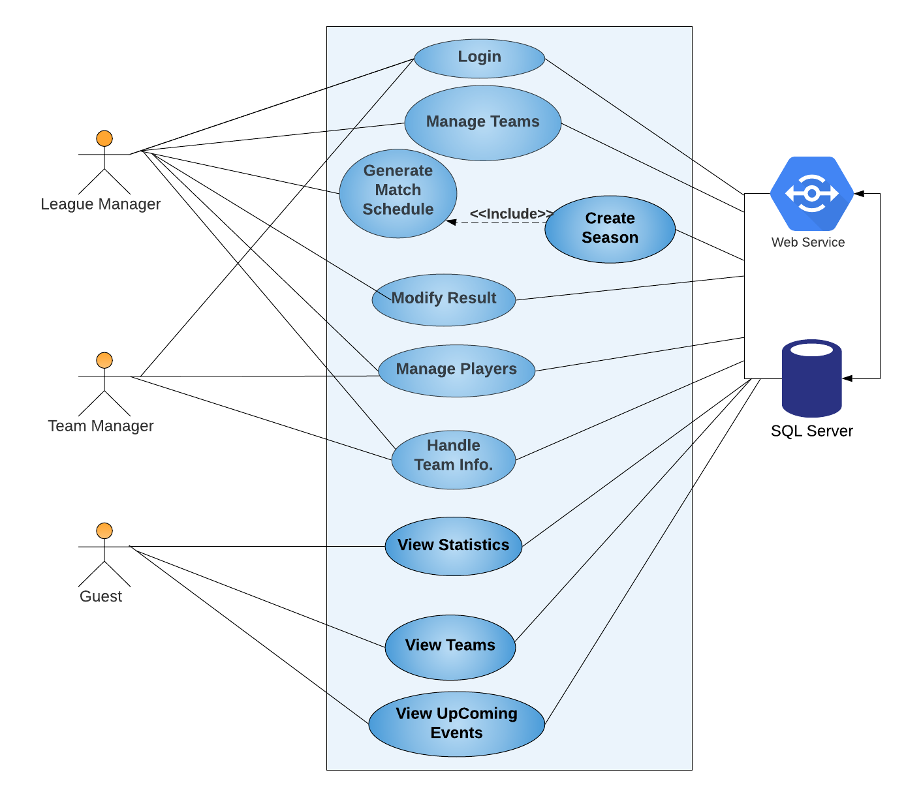

1. **Use Case Fully Dressed:**

|  |  |
| --- | --- |
| **Use Case Section** | **Comment** |
| **Use Case Name** | Manage Teams |
| **Scope** | Volley Viction Application |
| **Level** | User-Level |
| **Primary Actor** | League manager |
| **Stakeholders and Interests** | League manager: League manager must be able to access to functionality of an application. And, must be able to login to use an application. |
| **Preconditions** | League manager must be authenticated to an application and must have proper rights to access this application |
| **Success Guarantee (Post-Conditions)** | League manager must have created a page with all correct information. |
| **Main Success Scenario**  **(or Basic work-flow)** | League manager can add teams by adding information like team name, coach name, team logo etc. likewise league manager can delete team from the team list. |
| **Extensions (or Alternative work-flow)** | If League manager doesn’t know the flow of modifying then an application won’t move forward. |
| **Special Requirements** | League manager must have an android mobile. Touch screen UI on a flat panel monitor. Text must be visible from 1 meter. |
| **Frequency of Occurrence** | Every-time when the app is logged out or logging in as a league manager. |
| **Miscellaneous** | Can user do their activities offline? |

|  |  |
| --- | --- |
| **Use Case Section** | **Comment** |
| **Use Case Name** | Generate Match Schedule |
| **Scope** | Volley Viction Application |
| **Level** | User-Level |
| **Primary Actor** | League manager |
| **Stakeholders and Interests** | League manager: League manager should able to create schedule for matches. |
| **Preconditions** | League manager must be able to create a season, only that way application can proceed. |
| **Success Guarantee (Post-Conditions)** | League manager should have generated a page correct information with time, date and place. |
| **Main Success Scenario**  **(or Basic work-flow)** | League manager can create new match schedule where user can add information such as match timing, date, location, teams name etc. |
| **Extensions (or Alternative work-flow)** | If League manager doesn’t know the flow of creating a schedule for matches then an application won’t move forward. |
| **Special Requirements** | User have an android mobile. Touch screen UI on a large flat panel monitor. Text must be visible from 1 meter. |
| **Frequency of Occurrence** | Every-time when the user creates a new season for match. |
| **Miscellaneous** | Can user do their activities offline? |

1. **SEQUENCE DIAGRAM**

**League Manager**

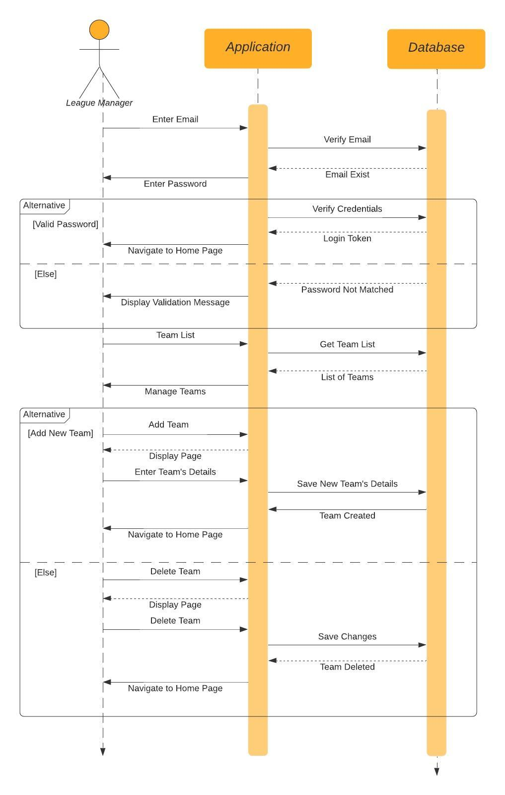

**2. Manage Player**

**3.Create/Add Match**

1. **CLASS DIAGRAM**

